

AY: 2022/23

CIS7029 - Social Media Analytics for Business

Module Leader : Dr Esyin Chew

**Student Name : VYSHNAVI**

**MUTHUMULA**

**Student ID : st20219772**

**Assignment Title: CUSTOMER SATISFACTION AND THEIR INTERESTS TOWARDS ROYAL ENFIELD**

**Table of Contents**

Biography 4

Abstract 4

Purpose 4

Design and methodology 4

Findings 4

Social or Business implications 4

Research implication 4

Introduction 5

Motivation....................................................................................................................................5

Importance of Social media in marketing....................................................................................5

Design Methodologies…………………………………………………………………………….7

Tools and techniques…………….…………………………………………………………………..…7

Justification of choice 13

Implementations 13

Key results 15

Visualizations 17

Business Story Telling……………………...……………………………………………………22

Conclusion ………………………...…...…………………….………………………………….23

Limitations…………………………………………………………………………………………24

Recommendations...…….…….………………………………………………………………….24

References 25

Appendix 26

**List of Figures**

1. Customer satisfaction principles…………………………………………………………...5

2. Royal Enfield 6HP outfit.......................................................................................................6

3. Design model.........................................................................................................................7

4. Web harvesting .....................................................................................................................7

5. Data miner pop up window...................................................................................................8

6. Data Miner Row selection.....................................................................................................9

7. Data Miner Column selection................................................................................................9

8. Data Miner Page selection.....................................................................................................9

9. Data Miner final step...........................................................................................................10

10. Downloading data..............................................................................................................11

11. Date conversion.................................................................................................................12

12. Cleaned data......................................................................................................................12

13. KNN Accuracy..................................................................................................................14

14. Logistic Regression Accuracy...........................................................................................14

15. Analysis Report.................................................................................................................15

16. Statistical Report...............................................................................................................16

17. Year wise Visual appearance ...........................................................................................17

18. Purpose of Travelling........................................................................................................18

19. Polarity Distribution..........................................................................................................18

20. Sentimental analysis Timeline..........................................................................................19

21. Twitter comments for Royal Enfield.................................................................................19

22. Year vs. Maintenance........................................................................................................20

23. Year vs. Performance........................................................................................................20

24. Mileage Rate.....................................................................................................................21

25. Overall Rating...................................................................................................................21

26. Year vs. Service Experience..............................................................................................22

27. Long-Term Profitability Performance Measures...............................................................22

**Biography:**

Vyshnavi Muthumula pursuing M.Sc. in Data Science at Cardiff Metropolitan University, United Kingdom. Pursued under graduation at VIT, Bhimavaram, India in 2019. Vyshnavi worked in Capgemini for 3 years as a Full stack developer and Backbase Modeller. As a part of research the author analyse the data which consists of customer reviews towards Royal Enfield. The researcher analysed the performance, maintenance cost, service experience, accuracy, and visual appearance of the Royal Enfield based on customer reviews.

**Abstract:**

In today’s world, customer plays important role for sales growth in the markets or organization. If the product designed based on customer’s satisfaction then the sale rate will increase 10 times than usual sale.

**Purpose:** The purpose of this research is to find the customer satisfaction towards Royal Enfield on various factors such as Mileage, Visual appearance, Performance, Service Experience, Maintenance cost, rating etc., in which help marketers to improve their product growth. Furthermore, it assists people in selecting the right product.

**Design/Methodology**: In this analysis researcher used Data miner to scrape the Royal Enfield data, Python for cleaning, Tableau for visualizations and sentimental analysis. Based on customer response sentimental analysis is performed using Python programming. The outcome of this analysis is to find the positive, neutral and negative reviews.

**Findings:** The outcomes are rather obvious. The majority of consumers favoured Royal Enfield because of its appearance and quality ride. Among the other qualities, comfort received the highest rating. In terms of technology, the ***Classic and Standard model*** bikes are identical, giving customers the impression that they are purchasing the classic bullet. According to the results, consumers are interested in Royal Enfield because it offers a good quantity of torque and a wonderful design. The average mileage for Royal Enfield Classic bike is 45 kmpl. According to study, Royal Enfield does not employ any third-party provider for brand advertising when compared to other brand companies.

**Social or Business implications:**

Analyzing aspects of client reviews will allow marketers to examine their product flaws and, if necessary, rectify them. In business, it is very important to find the limitations. According to this study, Enfield sales after 2018 are quite low. In this survey, mainly mileage, quality service, cost of maintenance, and ride comfort from the past 5 years are evaluated.

**Research limitations/implications:**

The researcher encountered difficulties when converting dates, but by using Python programming the problem is resolved. Due to a lack of accurate data, it was unable to divide the data by gender.

**Key words:** Data miner, Python, Tableau, Sentimental analysis.

**Introduction:**

**Motivation:**

Customer’s point of view plays an important role for product growth. Customer’s satisfaction is acknowledged as a company’s most valuable asset. In the two-wheeler automotive sector Royal Enfield is well-known brand globally. The main motivation of this study is to determine the customer reactions and awareness towards Royal Enfield. It also includes some of the factors that affect the satisfaction of Royal Enfield users. Those factors are Visual appearance, Maintenance cost, Service Experience, Ridding quality, Usage, Performance and Mileage.

The Royal Enfield has an all-metal structure with few plastic parts (excluding the Royal Enfield Himalayan) and can last decades of service if properly maintained. This is the only bike which is surviving from last 100 centuries.

**Importance of Social media in marketing:**

Most of the people use social networking sites such as Twitter, Facebook, Instagram and Review websites. According to researchers, social media is the largest platform where everyone is communicating with each other, such as customers sharing their ideas and marketers sharing their tactics. Customer satisfaction directly affects profits of the organization according to (Hoyer and MacInnis, 2001).

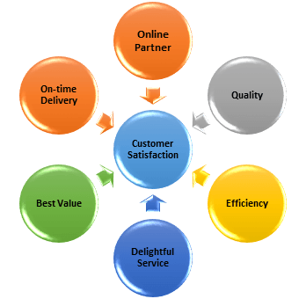

Fig 1: Customer satisfaction principles (Netdna-ssl.com, 2022)

Marketers are investing money in social media platforms for a number of reasons. They are listed below (Henderson, 2020).

1. To improve their brand.
2. For generating leads: By using these engagements customer and sellers can have greater experience which leads for better improvement of the product.
3. Marketers will get the opportunity to share your business details to customers so that customer can know about your business highlights and marketers can increase their brand names through small platform within short period.
4. It will help to make a good contact between customer and marketers.
5. Based on the comments or strategies of the other competitor on the social media platform, marketers can improve their strategies and gain customers easily.

**History about Royal Enfield**

Royal Enfield is the world’s oldest motorcycle. Eadie sold rifles part (**Enfield Rifle**) to Royal Small Arm. Later Eadie got profits because of **Royal Small Arm** group that’s why Eadie and Bob walker Smith decided to name their new bike as ***ROYAL ENFIELD.*** That’s how the name comes into picture. In short period Royal Enfield sales touched the cloud. They added new features to the bike like countershaft gearbox and chain drive which released as model 180 V-twin.The best part is that this bike was used during World War I as the platform for holding guns.

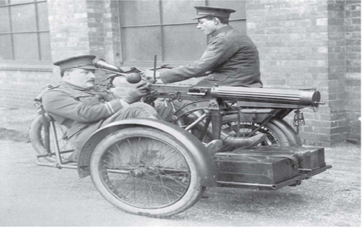

Fig 2: Royal Enfield 6HP outfit (Henshaw, 2020)

Redditch Company decided to tie up with India. In 1955 finally Redditch company partnered with Madras Motors then they formed ‘Enfield India’ and 350 cc Royal Enfield Bullet Bike was launched.

**Design Methodologies:**

**Tools and Techniques:** The tools used in this project are Data miner for scrapping customer reviews, Python programming for cleaning the data, Tableau is for visualizations and sentiment analysis is for finding the emotions of the customers based on reviews. Jupiter notebook is used for doing Python programming. It is an open source platform.

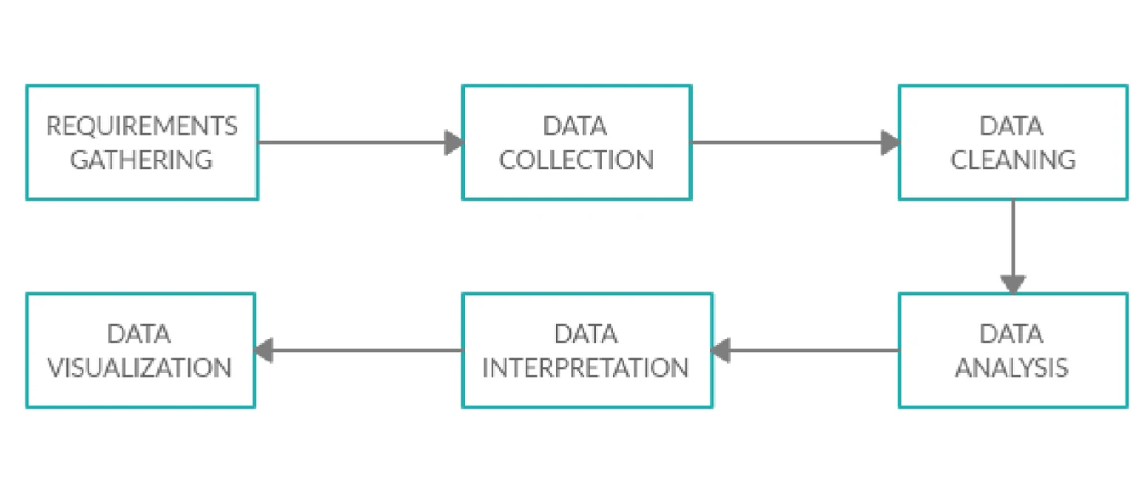

Fig 3: Design model

**Requirement gathering:** In this stage we need to gather the site where all the required information present based on your idea. This is the 1st stage and very important because all the analysis is depending on the data from that site which researcher going to scrape.

**Data collection:**

**Web harvesting:** Web harvesting or web scrapping means extracting the data from HTML pages (unstructured) into structured data driven format like .csv or .excel. There are several scrapping tools are present in the market such as Octoparse, data miner, web scrapper and by using Python language also we can scrape the data.

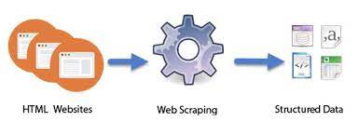

Fig 4: Web harvesting (Thewindowsclub.com, 2022)

**Data Mining:**

Data mining is a technique used by corporations to find patterns and in order to make better business judgments, relationships the data must be identified.

**Data Miner:** Data miner is a power tool which used to scrape the data from web page.

Within a less time user can scrape over 60,000 data with some easy and simple rules. If they want only preferred data from a webpage then they can write their own customized rules for extracting the data.

User has to create an account in Data miner through Gmail. Starting 500 page scrapping is free need to buy a plan.

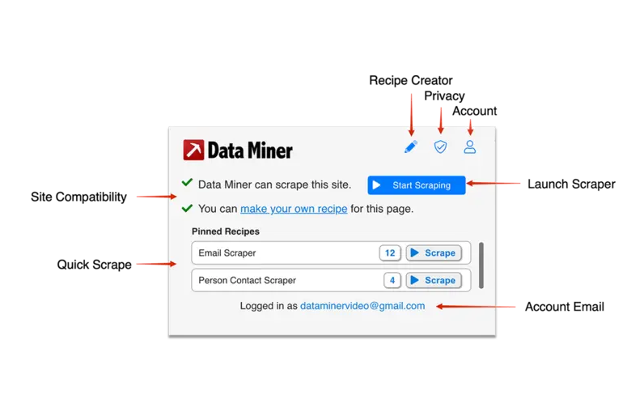

Fig 5: Data miner pop up window

**Steps to extract the data:**

1. Select the content which needed and then right click and select **Get similar** then it will redirect to Data miner then scrapping starts.
2. By using this method always user won’t be able to get the proper data, only limited columns data will be scrapped. In this study researcher faced this issue so created own recipe.
3. Just click on that **make your own recipe**. In step 2 select List / Search Page if they need multiple rows data.
4. Skip step 3 and go to step 4 which is selecting rows. Then select first two rows by using ***Easy row finder*** or user can go for ***Advanced finder*** where user select the items through HTML tags ->Hover on First row and ***enter 1*** then first row will be selected then hover on second row and ***type 2*** then second row will be selected.

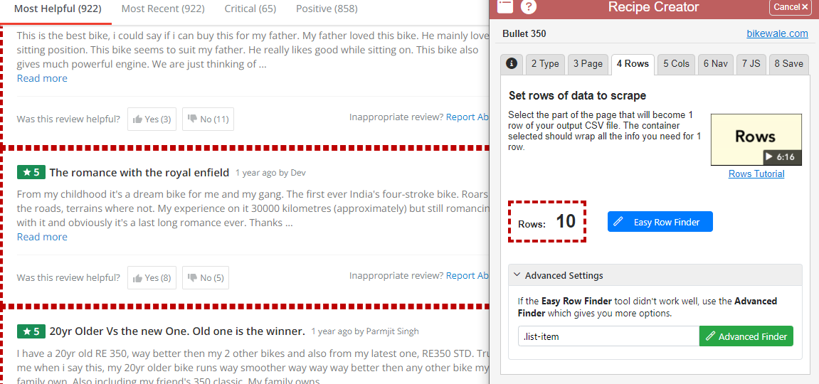

Fig 6: Data Miner Row selection

1. Go to step 5 for selecting columns. Hover on element which user want and then type **c**. Repeat the process for all the items.

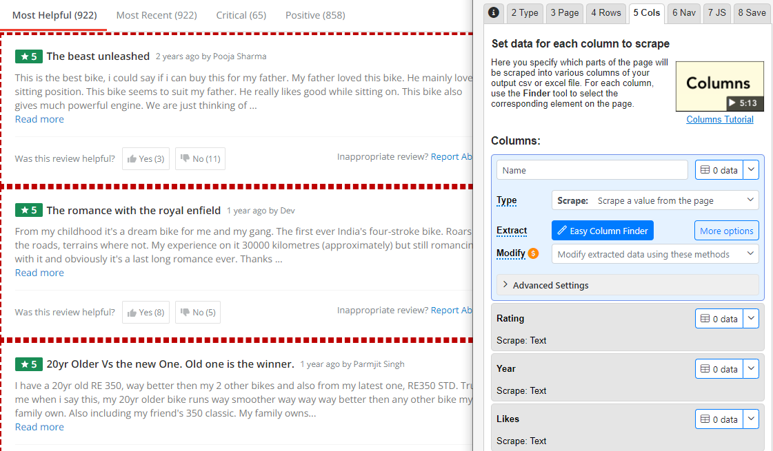

Fig 7: Data Miner Column selection

1. For auto pagination go to step 6. Click ***Easy Nav Finder*** then hover on ‘>’ or ’>>’ or ‘Next’ and then type **N**.

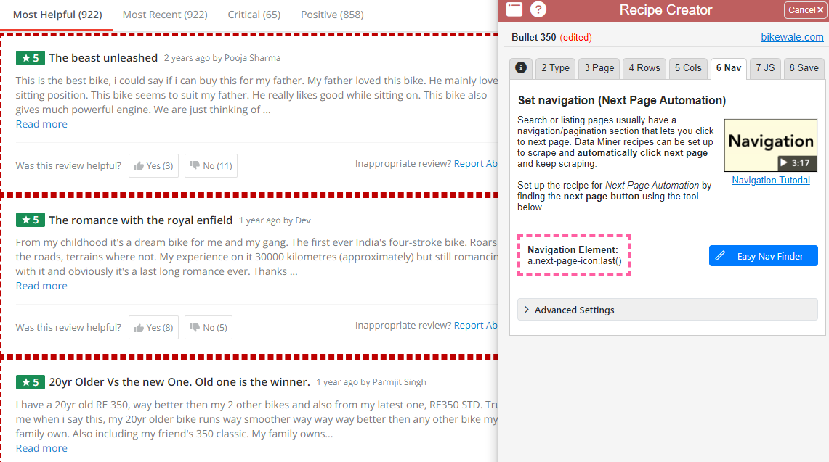

Fig 8: Data Miner Page selection

1. Step 7 is for modifying the JS. For this site there is no need of modifying any JS content.

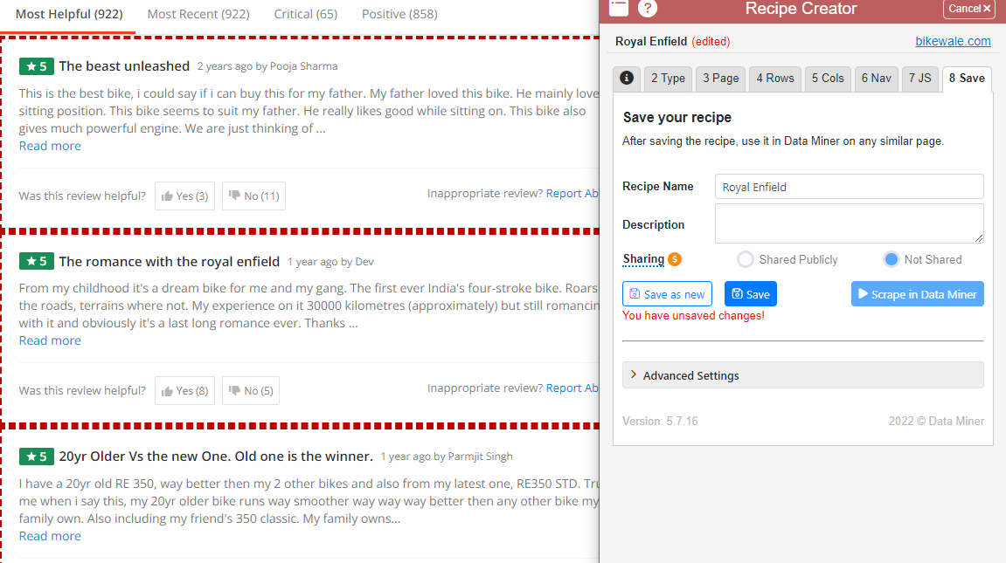

Fig 9: Data Miner final step

1. User can add how many pages they want to scrape. Then click on Scrape ‘n’ pages.

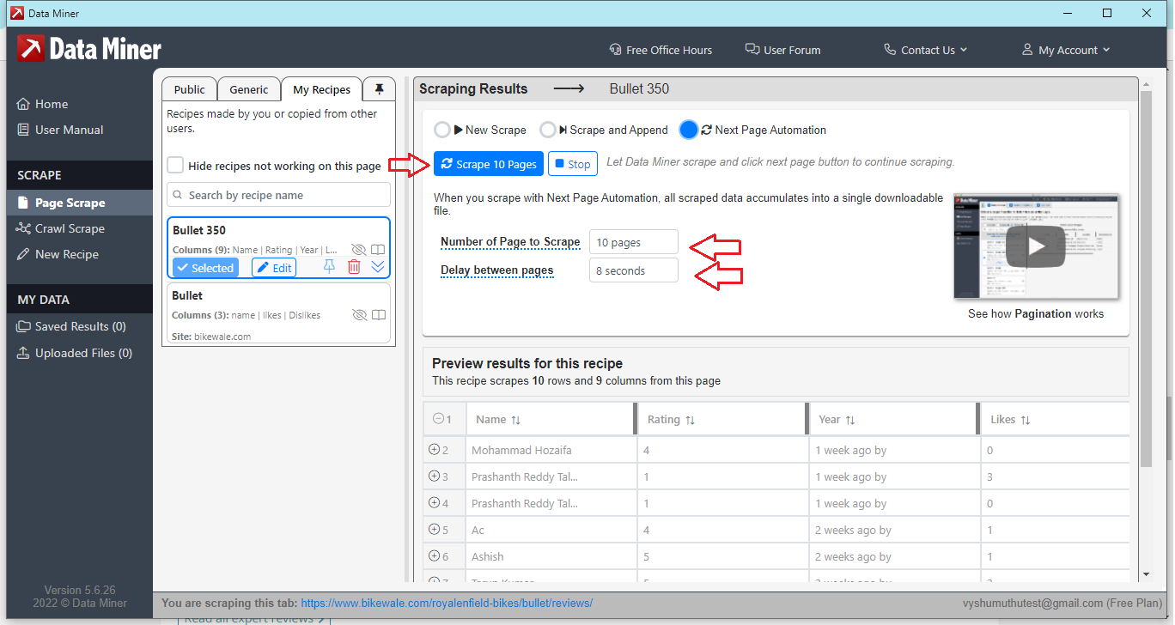

Fig 10: Downloading data

1. After scrapping just download the .csv file.

Why Data Miner:

1. Data miner is very secure and safe.
2. User can scrape the data without any issues because it is not a Bot.
3. It keeps data very private. Data miner never shares or sells data to third party people.
4. Automatic pagination is available.
5. Custom scrapping, Automatic scrapes, Fast table scrapes and with one click you can scrape so much data.

**Data Cleaning and Data Analysis:**

The output which got from Data miner contains special characters, null values and Date format is not acceptable for Data analysis. To rectify this issue data cleaning is required. Here in this analysis for cleaning the data user used ***Python programming language.*** Python is an open source and user friendly language. This language has many in-built libraries which helps developer to analysis the data easily and quickly. For that reason author preferred Python for cleaning the data and performed some statistical analysis.By using ***machine learning algorithms*** we can predict the ***accuracy of the Royal Enfield customer reviews data***.

Check whether there exists any missing values by using .isna() method. The result shows this data set has many missing values because there are total 7 features while writing the review and those are not mandatory fields so, it is user’s choice to select any 5 features. That’s why there are many null / missing values. For better analysis replace those values with 0.

The date column format needs to change because it is very difficult to analyse.

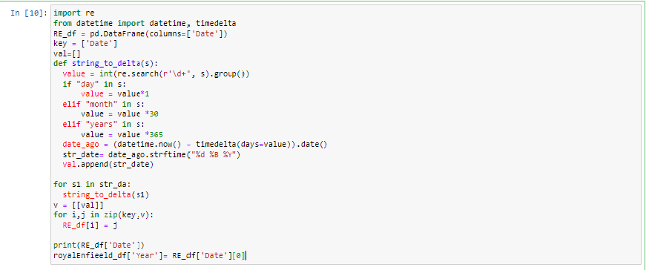

Fig 11: Date conversion

Final cleaned data shown below:

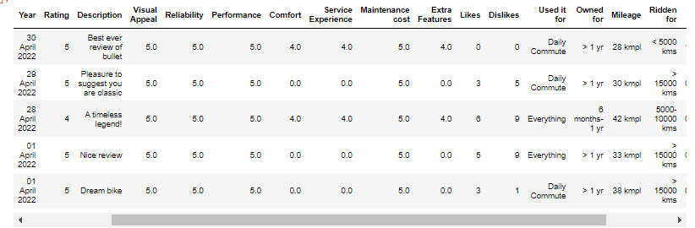

Fig 12: Cleaned data

**TABLEAU:** Tableau is a very powerful tool which helps to create interactive data visualizations using simple techniques. It is very easy to handle and user-friendly. In a business point of view marketers should need to be aware of their competitors so that they can improve their business that’s why finding critical or invisible insights in the data is very important. By using Tableau we can enable those hidden data patterns and it helps enterprises to improve their business in a user-friendly format. In recent days because of pandemic and new technologies the volume of the data increasing. So organizations need to pay more attention on data handling because of complexity. Tableau contains different versions such as Public, Server, Desktop and Online. By using ***R programming language*** and some other statistical technique’s Tableau internal team is maintaining things properly.

Finding Data:

There are some ***in-build data blending*** features in Tableau because of this user can easily enable new trends. The advantage of using tableau is user can ***deploy file to server*** and use if needed. Deploying the file into ***server*** is safer and up-to-date data will be available all the time. It enables user to make live connection (softwebsolutions, 2017).

Tableau comes up with complete package so that organizations prefer to their business.

**Why Tableau:**

1. User can create very complex visualization.
2. Switching from one visualization to another visualization is very quick and easy.
3. User can handle large amount of data at a time without any effort.
4. Integrating with multiple data sources can be done easily.
5. While processing the large amount of data we may face problems like crashing but tableau creates the visualizations without interruptions (Tyagi, n.d.).
6. It gives business the ability to perform complex nice visualizations using simple drag and drop manner.
7. Tableau is very interactive.
8. It has multiple charts so user can choose best chart.
9. By using R language we can reproduce and analyze it.
10. User can create multiple charts, dashboards and stories (Evolytics, 2017).

**Justification of Choice:**

Customer satisfaction is the major role for business growth. This research explores customer satisfaction with Royal Enfield on various factors like Mileage, Visual appearance, Performance, Service Experience, Maintenance cost and rating. Customers also show interest on brand of the product. When it comes to motorcycles, Royal Enfield is in the top ten in the world. Gathered the data from ***Bikewala*** site in which customer reviews were present. Scrapped the data using ***Data miner*** and converted the file into .csv file. Data miner is a power tool which used to scrape the data from web page. Data cleaning is done by using ***Python programming*** because Python provides good results. It has many in-build functions and libraries. It also serves several ***Machine learning algorithms*** which provide to predict the accuracy of the data. In this research performed two Machine learning algorithms called as **KNN and Logistic regression.** Visualizations are concluded using Tableau. It is very easy to handle and user-friendly.

**Implementations:**

In this analysis researcher performed two Algorithms for finding the ***accuracy of the Royal Enfield Customer reviews.*** Predicting accuracy is very important for any machine learning because it results how quality the data is. There are many algorithms present but used KNN and Logistic Regression because these two algorithms provide good accuracy for the customer reviews. These two algorithms result 76% and 74% accuracy because Royal Enfield data set has around 2,000 rows data.

**KNN:** K-Nearest Neighbours are used to find the nearest neighbours of the output. First it finds the nearest neighbours and then it calculates the number of each neighbours (Band, 2020).

For performing KNN we need to take input and output values(X and Y). Royal Enfield data set has many input parameters. In this Visual Appeal, Reliability, Performance, Service Experience, Maintenance cost, Extra Features and Comfort are the key features for choosing a bike and these factors affecting the final rating.

The result gives 63% for k=1.  
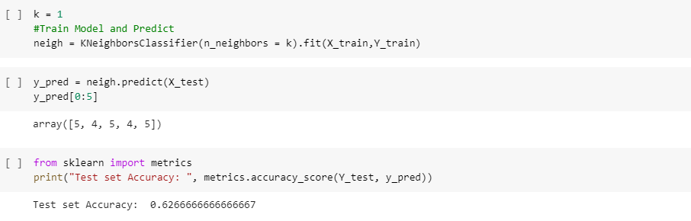

Fig 13: KNN Accuracy

When k=3 the accuracy is 73%.

**Logistic Regression:** It is used to find the probability of the discrete output for an input. The accuracy for this Royal Enfield data is 74%.

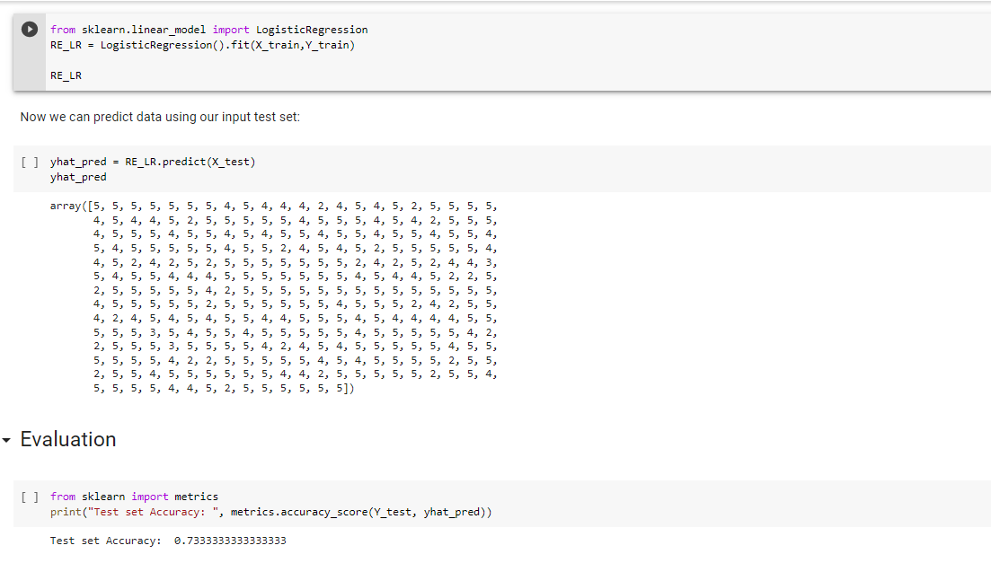

Fig 14: Logistic Regression Accuracy

**Key Results:**

The entire research focuses on customer satisfaction towards Royal Enfield bikes. The results are saying in 2018 the sales growth is high. The reason for this growth is that it announced the new Classic 500 Pegasus. In 2017 Royal Enfield sold 60,696 units in India. But in ***2018 it sold 74,697*** units the sales ***growth increased by 23%***. India exports Royal Enfield to other countries. Because of Classic 500 Pegasus edition the exports rate also increased. Total ***2,187 exports*** done in 2018 but in 2019 only 2049 units exported. The export growth increased by 7%. Overall Eicher Motors Limited sold 68,813 units of its 350cc bikes in India (Financialexpress, n.d.).

The final report based on the analysis shown in the table.

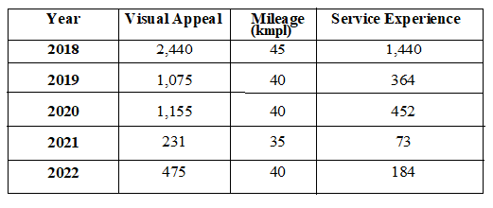

Fig 15: Analysis Report

After 2018 Royal Enfield growth decreased drastically because of not following trend. The new brands Honda, KTM, TVS, Moto corp etc., provided good features which attract customers towards those new bikes instead of Royal Enfield bikes. ***Bullet 350 is the best seller but still the sales are reduced by -16.71%.*** But international production still same because of new models in Royal Enfield such as ***Interceptor 650 and Continental GT 650***. In July 2019, Enfield faced -26.60% drops in sales. To resolve this issue Royal Enfield decided to launch new model in 2020 to reach the customer expectations in safety wise and BS-VI emission norms. (RushLane, 2019)

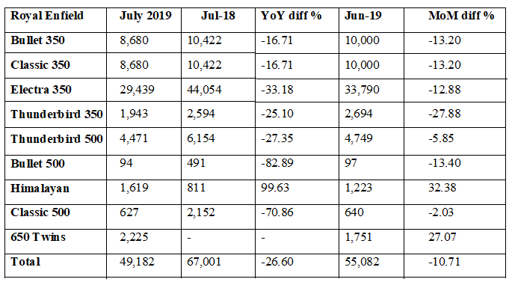

Fig 16: Statistical Report (RushLane, 2019)

In 2020 Royal Enfield announced 2020 Royal Enfield Classic 350 which has new version of clusters, switchgear and 650-twins. The bike's appearance is likewise completely outstanding, with a highly effective structure. The customers are satisfied with new model and sales also increased to 60,331. In 2021 semiconductors availability is very less globally so the production again dropped in 2021. But other brand bikes sales are rate are pretty constant because of their brand repetition. They are not effective in Social media platforms compared to others. Royal Enfield won’t provide advertisements as much as other brand motorcycles (RushLane, 2019).

The below listed points are based on analysis.

1. Torque love: Royal Enfield motorcycles offer enough low and high-end torque to handle practically any obstacle, with the exception of sand.

2. Quality of ride: Royal Enfield seats are made up with leather so customer feels so comfortable while driving the bike.

3. Visual Appearance**: It is built with metal and less plastic parts. If people maintained it properly then it lasts years. That is the reason Royal Enfield craze is still peaks today also.**

4. Absence of ABS: In Classic 350 engineers removed ABS.

5. Cost: The price of the bike is pretty high but it worth. Almost basic bike cost is 1,30,000 INR.

**Visualizations:**To provide a graphical representation of the results, the data was visualised using Tableau. There are many visualization tools but Tableau is one of the best visualization tools.

Based on the visualizations we can say customers are more satisfied with visual appearance.

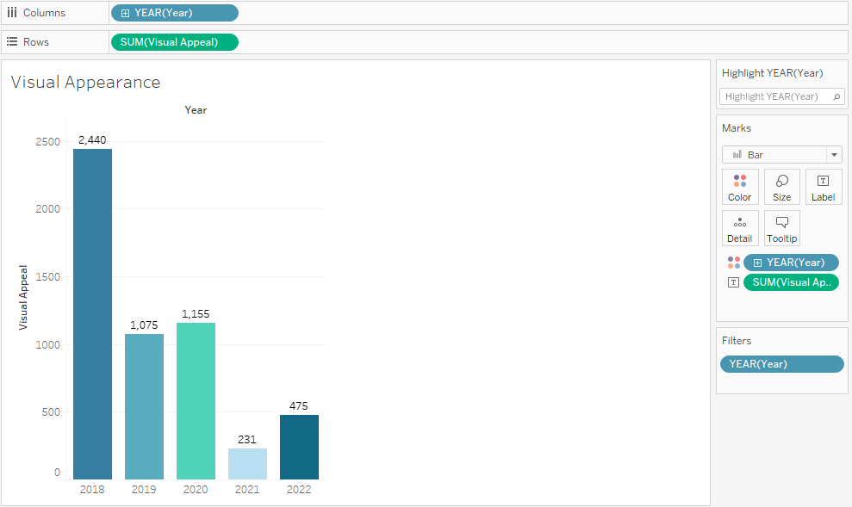

Fig 17: Year wise Visual appearance

The motorcycle mostly used for Daily commute we can say ***30% people are using for Daily purpose, 20% people are using for Everything, 15% people are using for Leisure Rides, 15% people are using for Tours as it looks are cool and only 10% people are using for occasional purpose***.

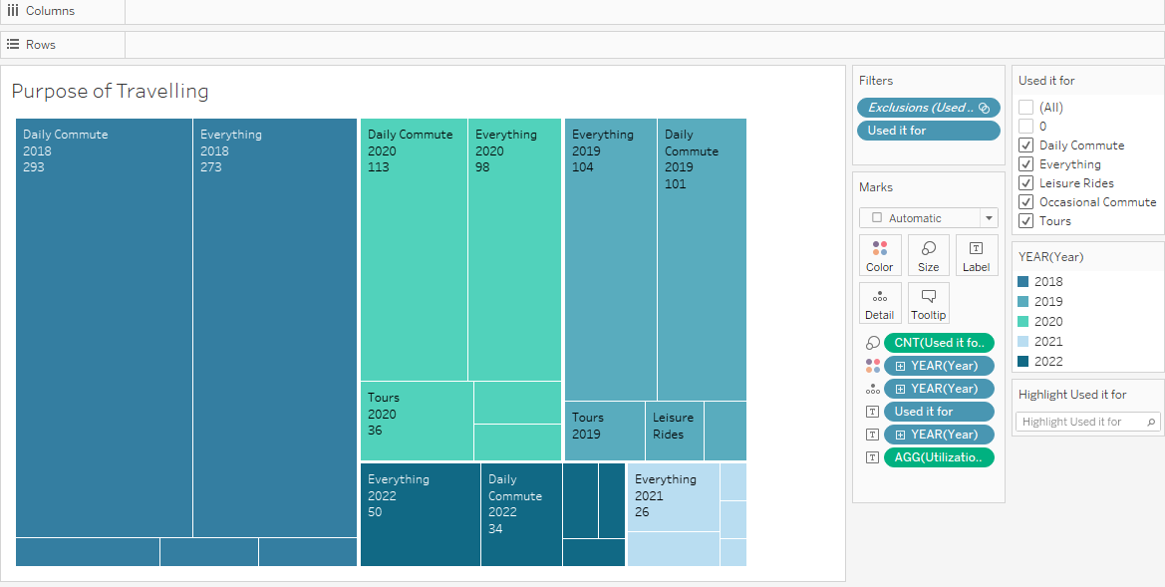

Fig 18: Purpose of Travelling

**Sentimental Analysis:** It is used to categorise opinions based on their textual content. By using sentimental analysis researcher concluded very less people dislike Royal Enfield motorcycle because of no proper customer service.

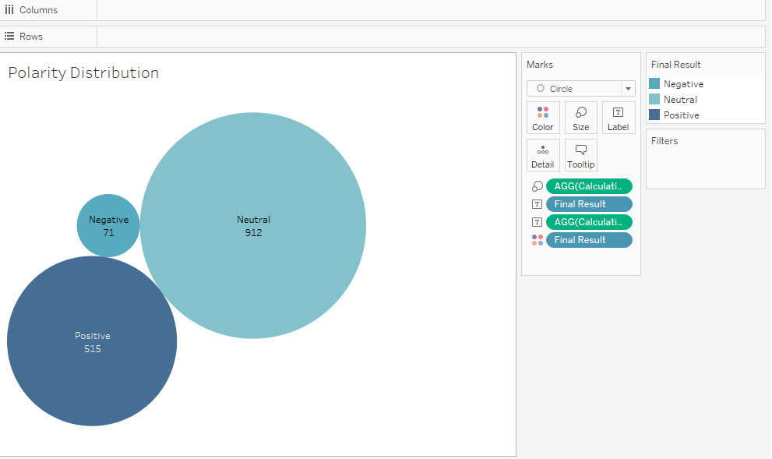

Fig 19: Polarity Distribution

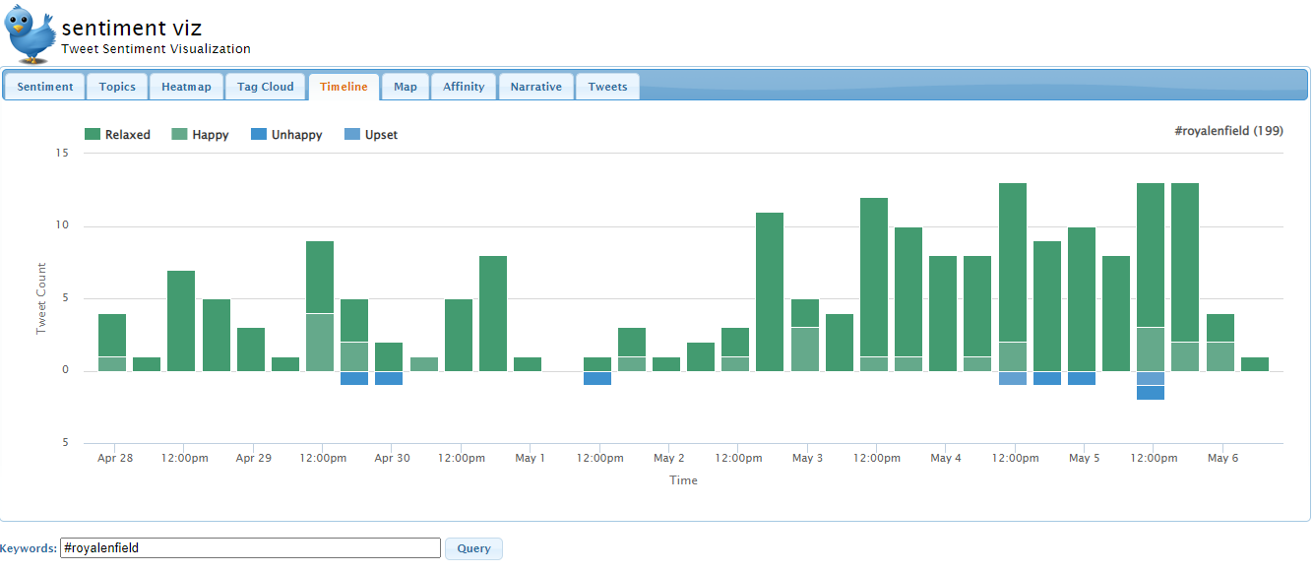

Fig 20: Sentimental analysis Timeline

The following are sentiment analysis for Royal Enfield Twitter reviews.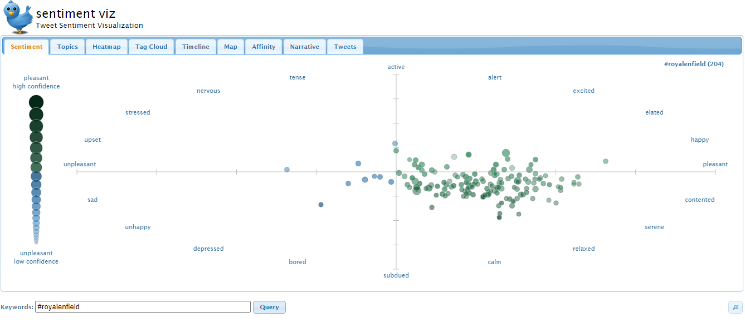

Fig 21: Twitter comments for Royal Enfield

The maintenance cost for Bullet 350 is quite high compared to other bikes. People are scared about this, but after 2018 the maintenance cost was gradually reducing.

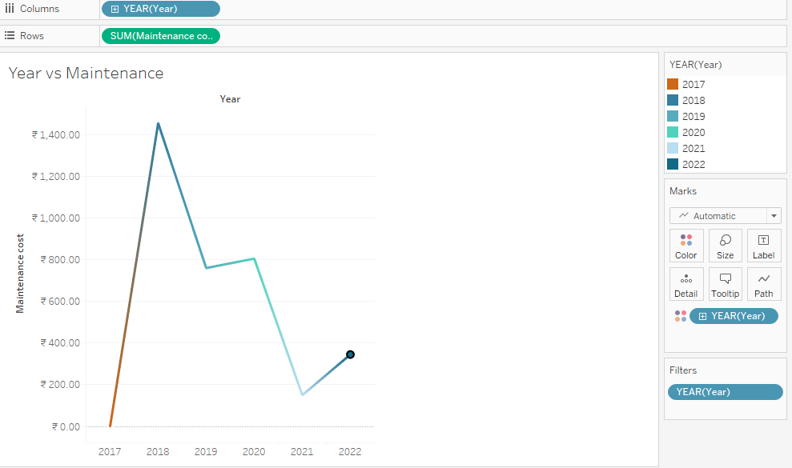

Fig 22: Year vs. Maintenance

Overall performance rating is good in 2018 later it decreased because of new features and new brands. Royal Enfield is unable to reach Customer expectation. The sales again starting raising after 2021 because of post pandemic Royal Enfield concentration is only to satisfy consumers.

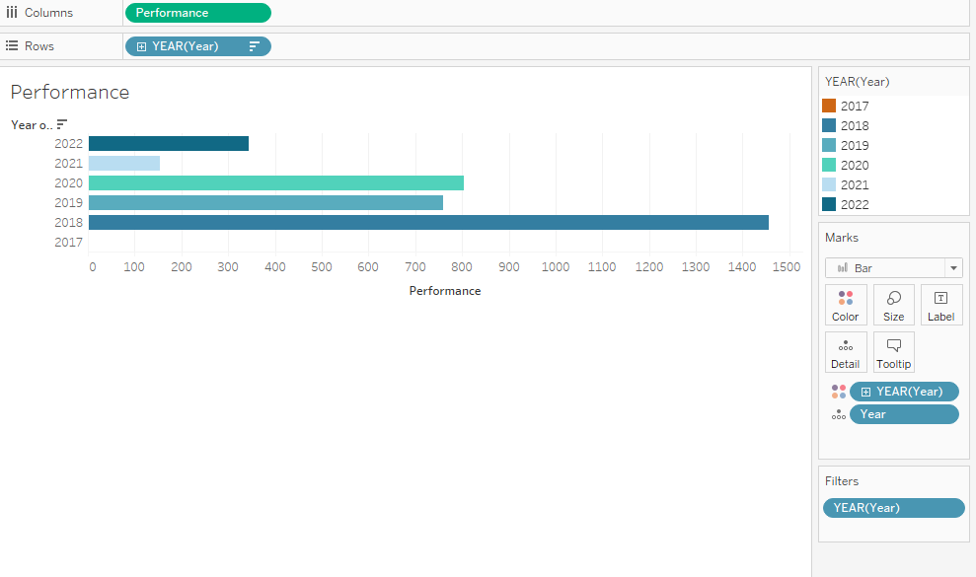

Fig 23: Year vs. Performance

The Mileage levels also increasing year by year. In 2018 the average mileage is 40kmpl, in 2019 45kmpl, in 2020 45kmpl, 2021 35kmpl this loss is because of new model and in 2022 the average mileage till today is 35kmpl. Hope this year the sales will reaches to sky.

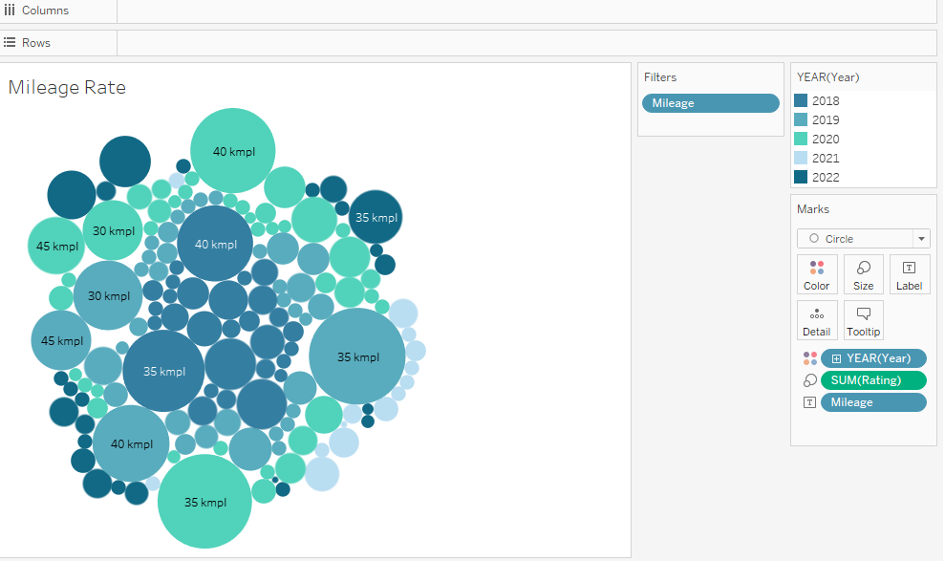

Fig 24: Mileage Rate

The overall rating based on user feedback is displayed below.

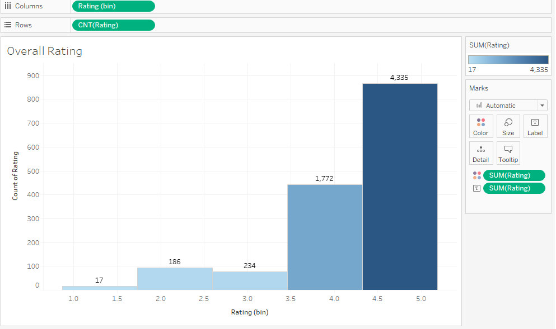

Fig 25: Overall Rating

Service Experience of the customer shown below.

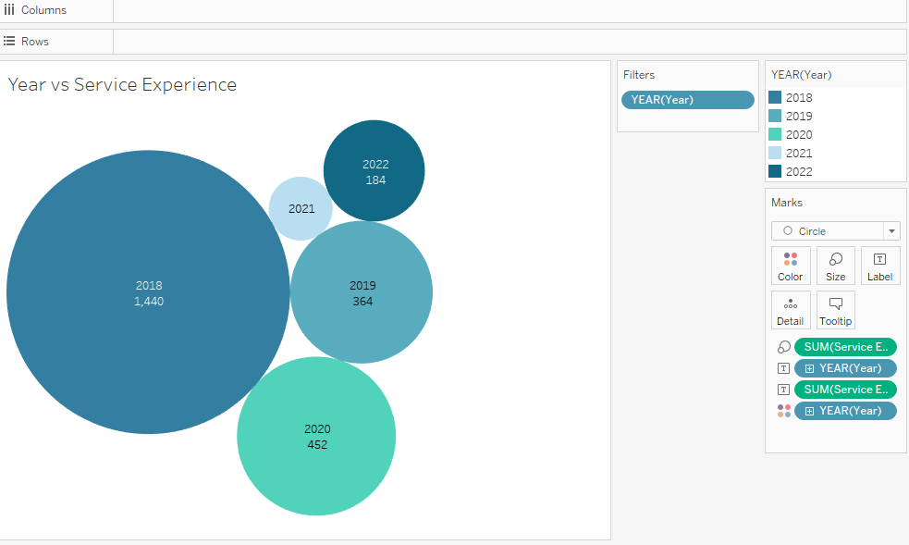

Fig 26: Year vs. Service Experience

**Business Story Telling:**

Singh (2006) mentioned that the profits of the company various based on Customer Satisfaction, Cost of the product, Brand name, Employee performance and product quality.

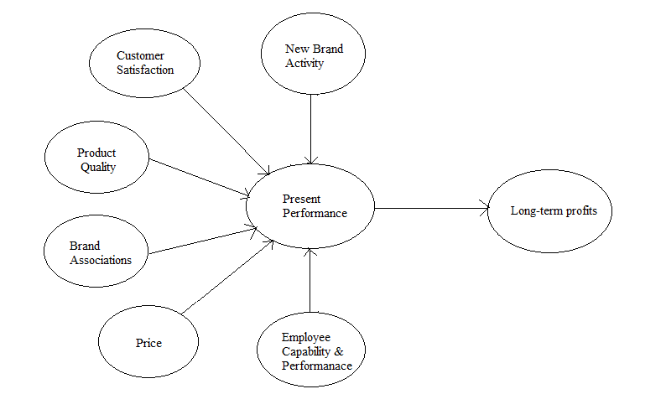**Fig 27:** Long-Term Profitability Performance Measures

**Royal Enfield Technology Centre:** Royal Enfield owned global technology centre at Bruntingthorpe, Leicestershire, in 2017. The reason for establishing this centre is to provide test track facilities. Along with these facilities it also provides strategies for product design, industrial tactics and research program management. The area of the centre is 3,000 square metres and includes studio design, labs, electrics, chassis build, model shop, metal fabrication, spray shop and repair shop. This is another reason for Royal Enfield growth (HAYWARDS OF CAMBRIDGE, n.d.).

Considering the economic growth Royal Enfield reached top 5th position in India. Royal Enfield taken overall Yamaha business and the Yamaha brand (6th position) is also have great reputation in India. Royal Enfield sold 4, 98,791 motorcycles in the year of 2015-2016 which is almost 53% from the previous year sales. Royal Enfield has risen to be one of India's leading motorbike companies as a result of its expansion along with Hero Moto Corp, Bajaj Auto, Honda Motorcycle and other Motors in India. Compared to last years the sales are increasing drastically almost sales are 50% more. The company decided to increase the sales, then they decided to start another plant in Oragadam because of this new plant the sales growth on 2018 is raised to 9,00,000. Yamaha tried to increase their sales but didn’t reach to Royal Enfield. Later RE introduced so many models one of the best model is Himayalan with 410cc. Customers love to Classic 350 bike is still crazy.

**Business owners decided to follow some rules to increase customer satisfaction as listed below:**

* Providing online help line centres: Because of pandemic everyone stayed at home and some service centres are closed. In this period many people faced issues if they have online help line centres at least customer can get an idea where the nearest centre available and if they explain what to do maybe customer can alone handle the issue.
* Advertising: Advertising is very important for the growth of product. By using advertiser’s product details will land into each and everyone’s smart devices. Not only through online in offline also owner’s increase their brand name by using posters.
* Face-to-face interaction with customers: Interacting with customers physically will be more effective for business growth because customer can easily communicate with employees to clarify their doubts and can share their views. This will lead greater improvement in customer ideas.
* Stick to your word: Customers are not stone hearted if company keeps their promises then customers are very loyal to their products (To, n.d.).
* Availability: When ever customer needs providers must be available (Sachin and Yadav, 2021).

**Conclusion:**

From this study researcher are able to analysis the satisfaction level of customers towards Royal Enfield. Apart from brand, Royal Enfield has various categories which makes customer to get attract towards it. They are Mileage, Visual appearance, how many days they used, Ridden for, Maintenance cost, Service providers, Price and comfort level. Despite the fact that ***Royal Enfield has numerous competitors, consumers are more satisfied with the product and are more eager to acquire it, which leads to a better good life***. This research study helps Royal Enfield owners to get an idea how customer is feeling about Royal Enfield whether they like it or not. Based on this report Marketers can find ***‘what are the things customers most loved’*** and ***‘drawbacks’*** about it, so that they have the ability to rectify or update their issues. The result of this entire research is that the customer satisfaction level on ***comfort and visual appeal is more*** compared to price of the bike. The study results Mileage levels are good. Based on Customer review Royal Enfield is lack of ***advertising*** the product compared to other products. But still brand name for Royal Enfield in market is popular even it is very old bike. COVID 19 also another reason for decreasing sales. The result of ***sentiment analysis*** is saying that most people preferred the bike because we have more ***positive reviews and younger, middle age people*** are mostly interested to buy this bike because of the model appearance and the sound. Mostly males are interested in this bike compared to females. ***Compared to 2018 the sales are less in 2019*** because of the new features and then dealers try to improve them, some what the growth is increased in 2020 but the financial crises are still the same.

**Limitations:**

1. The main issue faced for this analysis is while scrapping the data researcher able to scrape the data but when researcher checked the privacy concerns for that site it is saying that page is not allowed to scrape.
2. The entire research is based on ***Bikewala*** site and restricted to India so entire global review is not covered.
3. Past 5 years reviews are only analysed based on mileage, service experience, and maintenance cost and ride quality.
4. Gender segregation and price are not considered in this research because the review page don’t have those two parameters if those two fields are present then the report maybe very clear (To, n.d.).
5. This study is based on entire Royal Enfield particular model details review is not considered. If the review contains model view customer reviews we have the chance to consult which model is good and why it is good compared to other model.

**Recommendations:**

1. If the site makes all the fields mandatory while rating it provides more accuracy and accurate statistics.
2. The Royal Enfield data set should include more rows to allow greater computational analysis.
3. According to the researcher, the problem with date conversion may be overcome if they utilise another data scraping technology.
4. Apart from Data miner there are other scrapping tools also which gives proper data.
5. The Tableau server is crashing some times while publishing.
6. Complaints from customers should be handled as soon as possible.
7. To increase earnings, Royal Enfield suppliers should focus on people who are switching to other manufacturers.

**References:**

Batt, S., Grealis, T., Harmon, O. and Tomolonis, P., 2020. Learning Tableau: A data visualization tool. *The Journal of Economic Education*, *51*(3-4), pp.317-328.

Hoelscher, J. and Mortimer, A., 2018. Using Tableau to visualize data and drive decision-making. *Journal of Accounting Education*, *44*, pp.49-59.

Hoelscher, J. and Mortimer, A., 2018. Using Tableau to visualize data and drive decision-making. *Journal of Accounting Education*, *44*, pp.49-59.

Tyagi, N. (n.d.). *What is Tableau? Working and Key Features | Analytics Steps*. [online] www.analyticssteps.com. Available at: https://www.analyticssteps.com/blogs/why-is-tableau-used-for-read-the-working-and-key-features-of-tableau.

‌Evolytics. (2017). *Top 5 Reasons Your Company Needs Tableau*. [online] Available at: https://evolytics.com/blog/5-reasons-your-company-needs-tableau/.

Marill, J.L., Boyko, A., Ashenfelder, M. and Graham, L., 2004, June. Tools and techniques for harvesting the World Wide Web. In *Proceedings of the 2004 Joint ACM/IEEE Conference on Digital Libraries, 2004.* (p. 403). IEEE.

Gatterbauer, W., 2009. Web Harvesting.

Leinweber, D.J., 2007. Stupid data miner tricks: overfitting the S&P 500. *The Journal of Investing*, *16*(1), pp.15-22.

Albanese, D., Visintainer, R., Merler, S., Riccadonna, S., Jurman, G. and Furlanello, C., 2012. mlpy: Machine learning python. *arXiv preprint arXiv:1202.6548*.

Vukmir, R.B., 2006. Customer satisfaction. *International Journal of Health Care Quality Assurance*.

Hamzah, A.A. and Shamsudin, M.F., 2020. Why customer satisfaction is important to business?. *Journal of Undergraduate Social Science and Technology*, *1*(1).

Yussoff, N.M. and Nayan, S.M., 2020. Review on customer satisfaction. *Journal of Undergraduate Social Science and Technology*, *2*(2).

Singh, H., 2006. The importance of customer satisfaction in relation to customer loyalty and retention. *Academy of Marketing Science*, *60*(193-225), p.46.

Kishan, K.B. and Hemalatha, K.G., 2021. A Study on Consumer Perception and Satisfaction towards Royal Enfield. *International Journal of Recent Advances in Multidisciplinary Topics*, *2*(2), pp.20-21.

Manikandan, A. and Karthik, V., 2022. A STUDY ON CUSTOMER SATISFACTION TOWARDS ROYAL ENFIELD WITH SPECIAL REFERENCE TO PALANI TALUK. *EPRA International Journal of Multidisciplinary Research (IJMR)*, *8*(3), pp.37-44.

Haralayya, B., 2022. Impact of Ratio Analysis on Financial Performance in Royal Enfield (Bhavani Motors) Bidar*.*Iconic Research And Engineering Journals, 5(9), pp.207-222.

CHAUHAN, D., 2020. A STUDY ON CUSTOMER SATISFACTION TOWARDS ROYAL ENFIELD BIKES, DELHI-NCR”.

Shetty, A., 2016. A Study on Consumer satisfaction towards Royal Enfield bikes with special reference to Veenu Frontline automobiles. SDM College of Business Management Mangalore.

Megaladevi, P. and Vengaiyan, M.V., 2019. A STUDY ON SATISFACTION LEVEL OF CONSUMERS TOWARDS ROYAL ENFIELD IN TIRUPUR DISTRICT. *NOLEGEIN-Journal of Consumer Behavior & Market Research*, *2*(2), pp.20-24.

SUGUNA, S., EFFECTIVENESS OF MARKETING STRATEGIES TOWARDS ROYAL ENFIELD AT DHARMAPURI DISTRICT.

**Appendix:**

[st20219772 Royal Enfield | Tableau Public](https://public.tableau.com/app/profile/vyshnavi.muthumula/viz/st20219772RoyalEnfield/YearvsRating)

Scrapped Data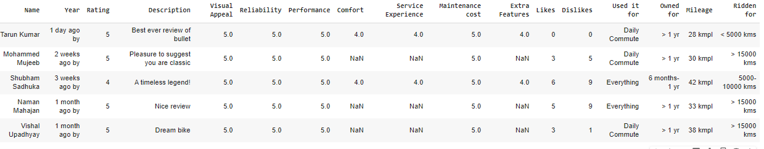Cleaned data